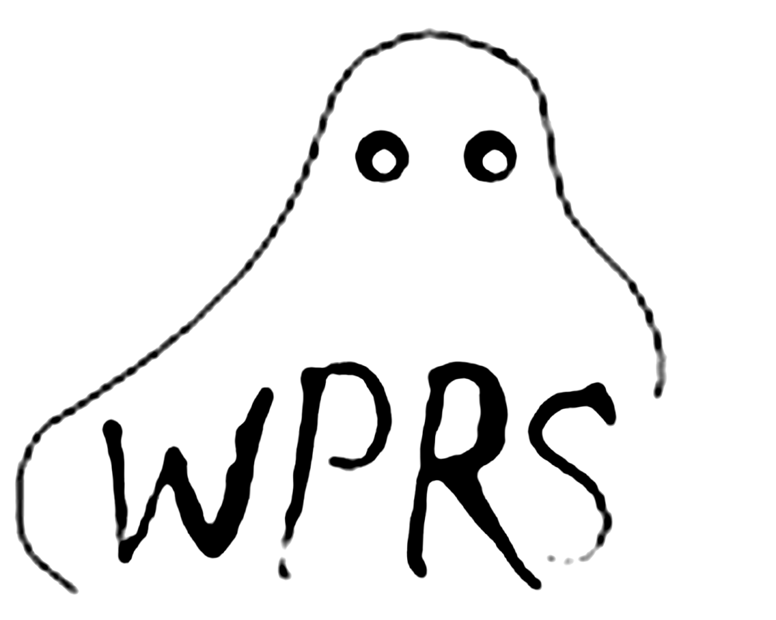

THE WAUSAU PARANORMAL RESEARCH SOCIETY PRESENTS
OUR 22nd ANNUAL
“DOWNTOWN WAUSAU HAUNTED HISTORY TOURS”
~Tour Several Historic Sites in Haunted Downtown Wausau with the (WPRS) WAUSAU PARANORMAL RESEARCH SOCIETY~
Learn about the history and haunts in Wausau. Learn about the mysterious woman in white haunting a 3rd floor business. Cyrus, Martha and Eddie as well as others from Wausau’s past. Uncover Wausau’s hidden paranormal history on this GUIDED walking tour of Several haunted locations in the downtown Wausau area. Stories will be presented by costumed historical characters at each location. Come and experience our “INTERACTIVE TOURS”
~After you obtain your ticket(s), feel free to purchase drinks from the bar and check out our equipment room. Relax comfortably in the Elk’s gathering area while you wait for your tour to leave~
WHERE: TOURS BEGIN AT THE WAUSAU ELKS LODGE #248, 414 SCOTT STREET IN WAUSAU, WISCONSIN. PLEASE USE THE MAIN ENTRANCE LOCATED BY THE GHOST TOUR BANNER.
WHEN: THESE GUIDED TOURS ARE CONDUCTED SATURDAY, OCTOBER 19th AND OCTOBER 26th FROM 5:30 PM TO 8 PM. TOURS WILL LEAVE APPROXIMATELY EVERY 30 MINUTES STARTING AT 5:30PM. TOURS LAST APPROXIMATELY 1½ HOURS.
HOW: TICKETS CAN ONLY BE PURCHASED AT THE TIME OF TOURS AT THE ELKS LODGE IN THE ELK’S MAIN LEVEL. A PORTION OF EACH TICKET SOLD WILL GO TO SEVERAL LOCAL CHARITIES. FUNDING WILL ALSO GO TO THE SHARE YOUR HOLIDAYS PROGRAM, WHICH DIRECTLY HELPS STOCK OUR LOCAL FOOD PANTRIES. EACH TOUR SIZE IS LIMITED FOR QUALITY PURPOSES AND WHEN IT IS FULL YOU WILL BE DIRECTED TO THE NEXT AVAILABLE TOUR TIME.
COST: $10.00 PER PERSON, CHILDREN 8 YEARS OLD AND UNDER ARE FREE. TOURS WILL BE HELD REGARDLESS OF THE WEATHER CONDITIONS. NO REFUNDS ON TICKETS PURCHASED. WE RESERVE THE RIGHT TO LIMIT OUR TOUR SIZES.
AUTOGRAPHED COPIES OF OUR BOOK “HAUNTED WAUSAU, THE GHOSTLY HISTORY OF BIG BULL FALLS”, WILL BE AVAILABLE FOR PURCHASE DURING THE TOURS, WHILE OUR SUPPLIES LAST!
NOTE: This is an outside guided walking tour and often the weather can be unpredictable, please dress appropriately for the weather conditions for maximum comfort.
CHECK OUT OUR LOCAL BOOK “HAUNTED WAUSAU”
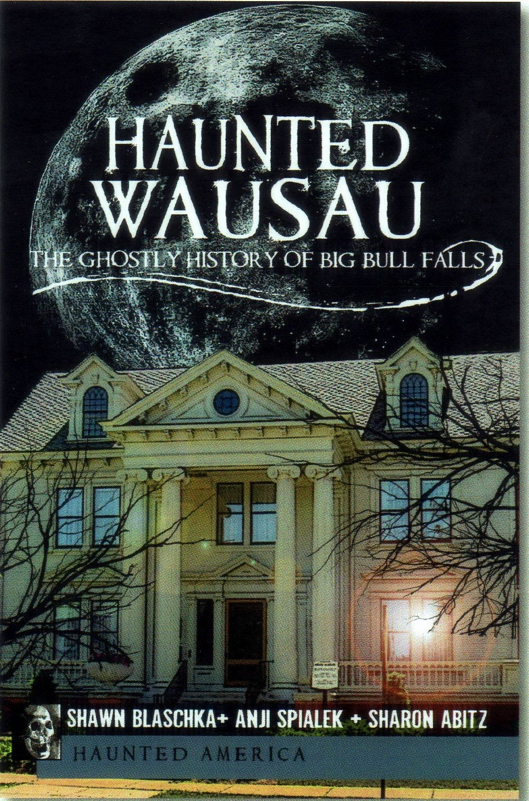
OUR BOOK IS AVAILABLE AND ON SALE AT THE FOLLOWING LOCATIONS:
DURING OUR GHOST TOURS
JAHNKE BOOKSTORE
BARNES AND NOBLE
WALGREENS
AMAZON
OR CAN BE ORDERED ONLINE AT
www.arcadiapublishing.com/books?searchText=HAUNTED%20WAUSAU
WWW.WPRS.NET

