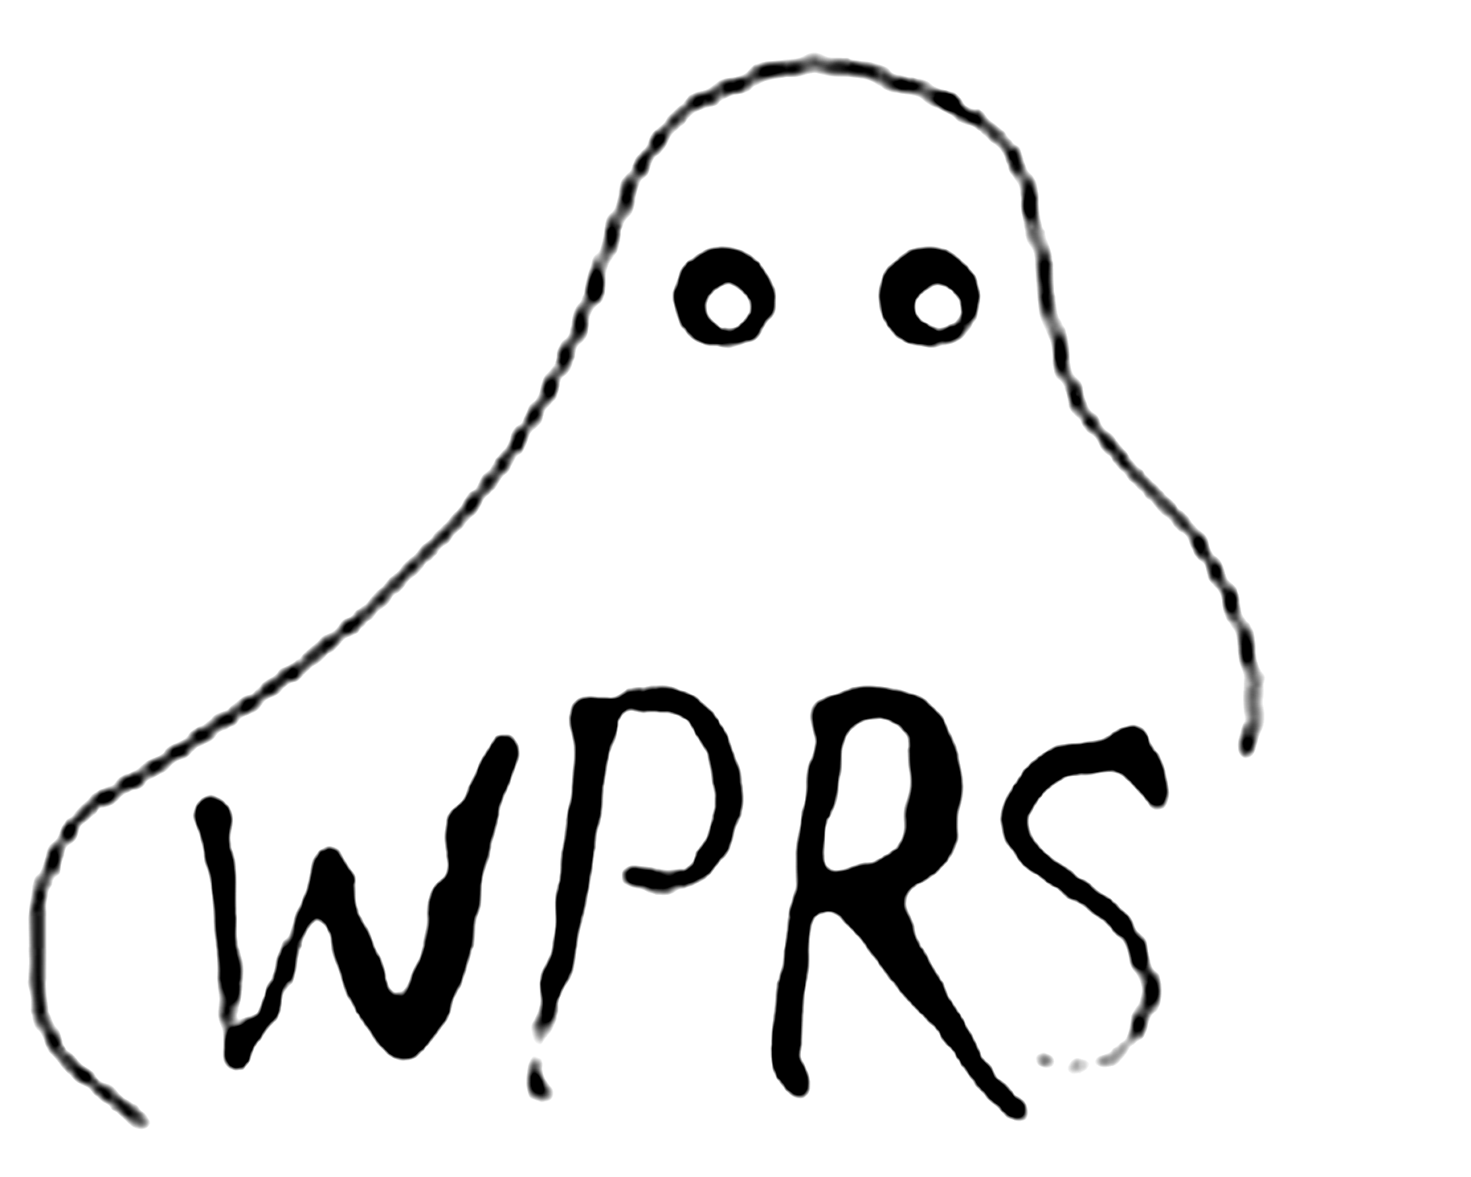

THE WAUSAU PARANORMAL RESEARCH SOCIETY PRESENTS
OUR 22nd ANNUAL DOWNTOWN WAUSAU “ORIGINAL” HAUNTED WALKING TOURS
“TWO FRIDAY’S ONLY”
~Tour Historic and Haunted Downtown Wausau with the (WPRS) WAUSAU PARANORMAL RESEARCH SOCIETY~
~Learn about the history and haunts of the Yawkey’s, Woodson’s, an early 20th century maid, the 19th century feuding dentist’s, Eddie the janitor, Larry, haunted churches and the woman in white. Uncover Wausau’s hidden paranormal history on this guided walking tour of several haunted locations in the downtown area.
WHERE: TOURS BEGIN IN FRONT OF THE WAUSAU ELKS LODGE #248, 414 SCOTT STREET IN WAUSAU, WISCONSIN. YOUR TOUR GUIDE WILL MEET YOU BY THE FRONT ENTRANCE.
WHEN: THESE GUIDED WALKING TOURS ARE CONDUCTED FRIDAY OCTOBER 18th AND OCTOBER 25th. THREE TOURS WILL BE OFFERED, ONE AT 6, 7 AND 8:00PM.
HOW: TICKETS CAN ONLY BE PURCHASED ONLINE. CONTACT BETSY DUGINSKI THROUGH OUR FACEBOOK SITE TO RESERVE TICKETS. A PORTION OF EACH TICKET SOLD WILL GO TO THE SHARE YOUR HOLIDAYS PROGRAM (THIS PROGRAM DIRECTLY HELPS STOCK OUR LOCAL FOOD PANTRIES) AND ALSO TO OTHER LOCAL CHARITIES IN OUR AREA. EACH TOUR SIZE IS LIMITED FOR QUALITY PURPOSES.
COST: $10.00 PER PERSON, TOURS WILL BE HELD REGARDLESS OF THE WEATHER CONDITIONS. NO REFUNDS ON TICKETS PURCHASED. WE RESERVE THE RIGHT TO LIMIT OUR TOUR SIZES.
NOTE: This is an outside guided walking tour and often the weather can be unpredictable, please dress appropriately for the weather conditions for maximum comfort.

